**NAME: PRAKHAR MISHRA**

**DATE: 23/01/2024**

**QUESTIONS**

1. **Demonstration of GROUP BY ROLLUP statement.  
     
   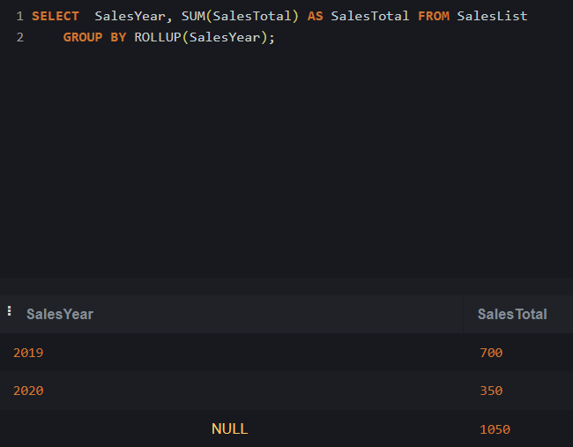**
2. **Demonstration of Roll Up**

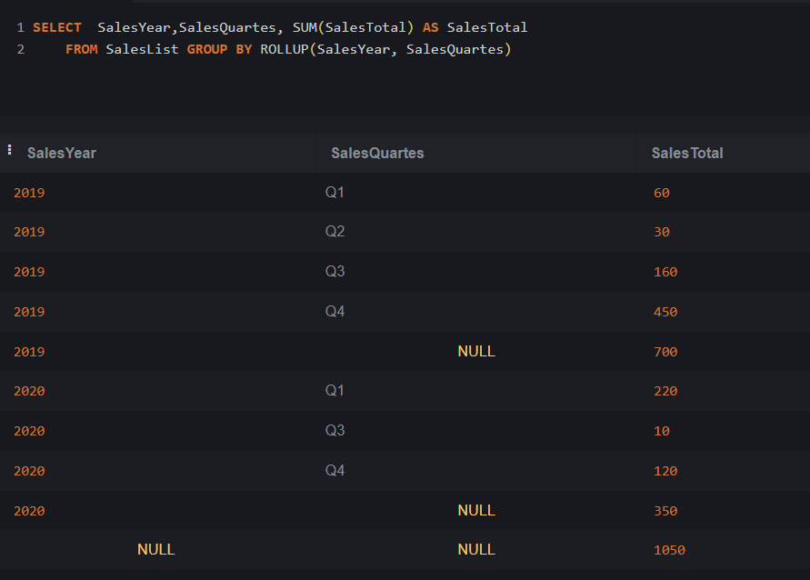

1. **Demonstration of Roll Up.**

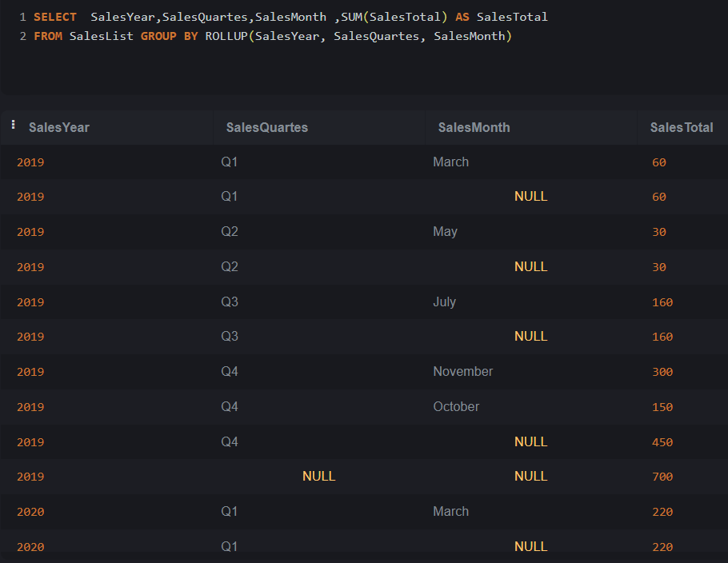

1. **Demonstration of GROUPING.**

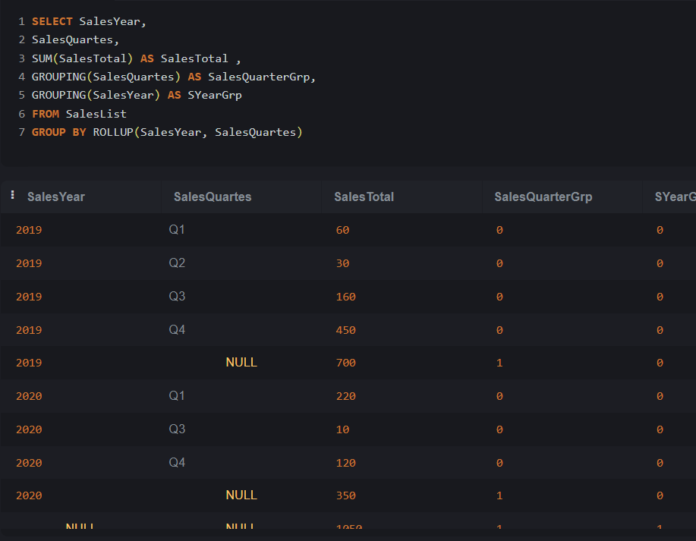

1. **Demonstration of CASE, GROUPING together.**

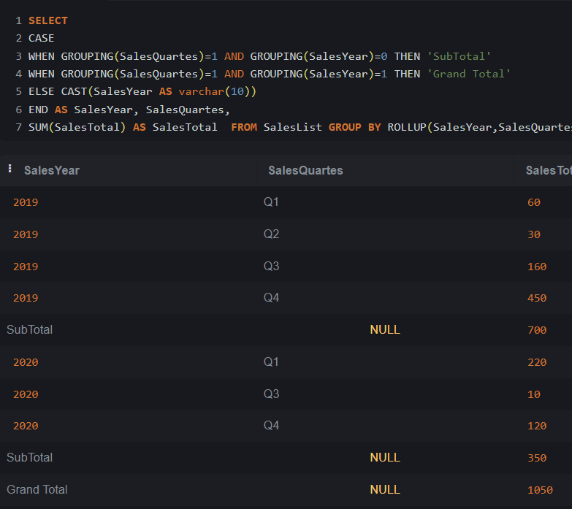

1. **Demonstration of ROW_NUMBER(), OVER().**

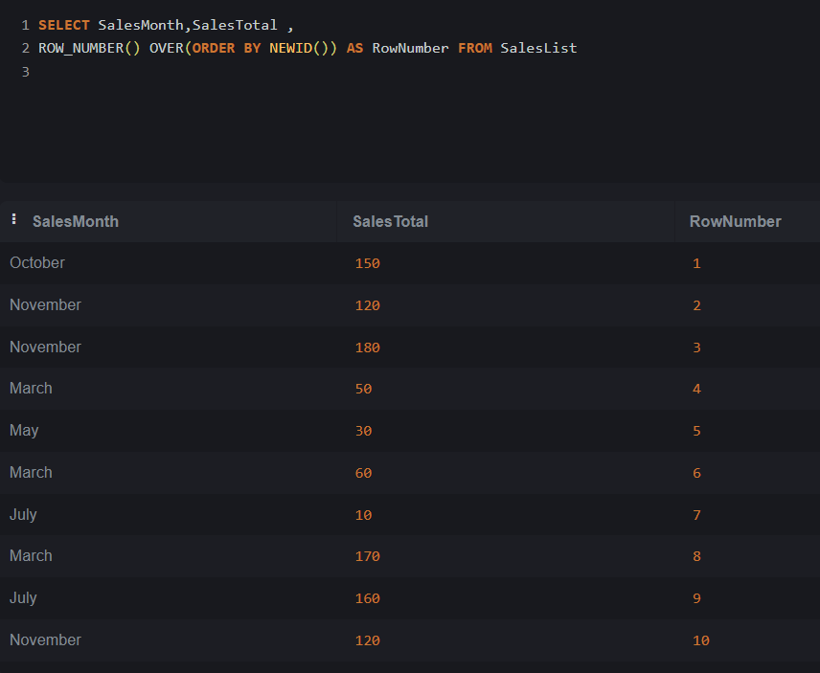

1. **Demonstration of GROUPING SETS.**

